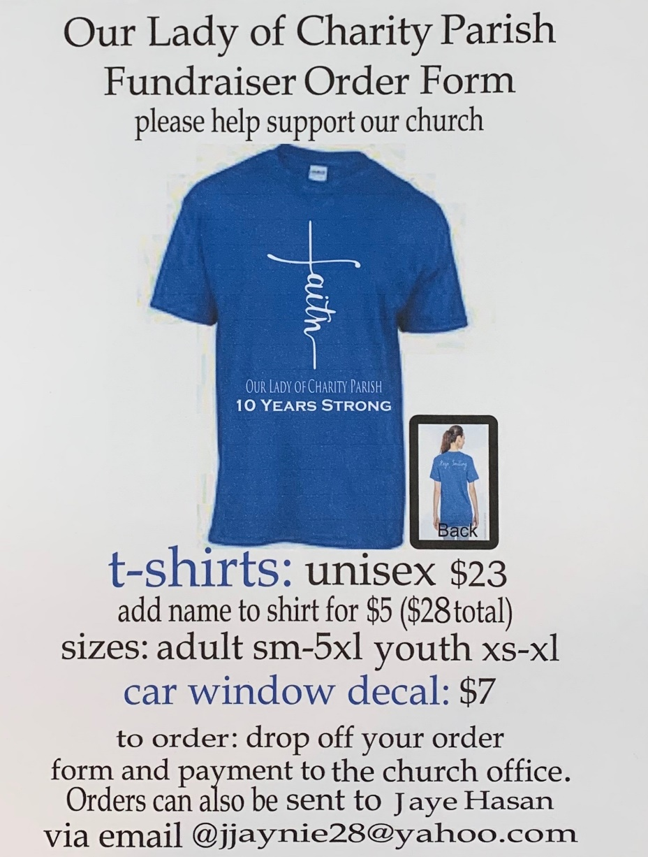

Name:________________________________________________

Size:____________________

Phone number:_______________

Add name on sleeve? ($5 extra)____________________________

Car window decal _________________