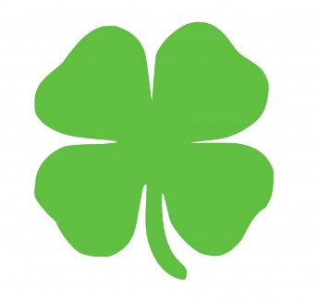
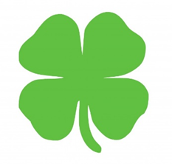
Irish Sweepstakes
Winners
Grand Prize: Tom Sutton
2nd Prize: Bob Penders
3rd Prize: Mary Jo Feeley
4th Prize: Madonna Fink
5th Prize: Dave and Margie Jawarski
6th Prize: Sr. Mary Gormley
Geraldine Zilka
Linda Pasin
Tony and Cathy Bevelogua
Mary Klien
Mary Lou Burger
Anne O’Connell
Sister Pauline’s Friends
Molly Sheehan
Mary Lu and Jim Zern
7th Prize: Karen Brant
Jane Driscoll
Tom Kuhn
Jerry Steck
Aaron and Julie Williams

